

**GENERAL HUMAN BIOLOGY – YEAR 11**

**TASK 1 – Microscope Slides and Science Inquiry Skills**

**WEIGHTING: 5%**

**NAME: ___________________________________**

**DATE: _____________________ MARK: _____ /37 = _____ %**

**Part A: Identify the unknown samples** (**12 marks)**

1. Look at the slides under a microscope to determine which of the slides is: (3 marks)

Red Blood cell, Liver Cell and cerebral cortex

|  |  |
| --- | --- |
| slide | Identity |
| Green |  |
| Orange |  |
| Black |  |

1. Explain how you knew you had correctly identified each slide (3 marks)

1. Using the images below determine which is the healthy tissue and which is unhealthy (2 marks)

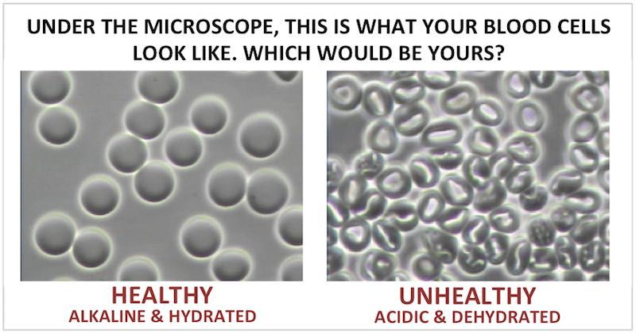

Identity:

1. How did you distinguish between the healthy and unhealthy tissue (2 marks)

1. Nikki looked through a microscope and saw lots of black dots in a pancreatic cell but when she looked at a blood cell she only saw a few. Explain this statement in detail. (3 marks)

**Part B: Scientific Drawing** (**11 marks)**

1. For one of the slides from question 1 draw a scientific diagram in the circle below (5 marks)
2. Before removing the slide show the teacher (2 marks)
3. Collect a microscope slide with the letter ‘e’ on it. Place it on the stage and in the space below, draw what you can see when looking down the eyepiece on the lowest magnification (1 mark)
4. Describe what has happened to the image? What do you think is inside the microscope that causes this?

(3 marks)

**Part C: Science Inquiry skills (14 marks)**

1. Students wanted to investigate the effect of hypotonic and hypertonic solutions of the shape of red blood cells.
   1. Using the pictures below, write a hypothesis to predict what will happen when a red blood cell are placed in a hypotonic solution. (2 marks)

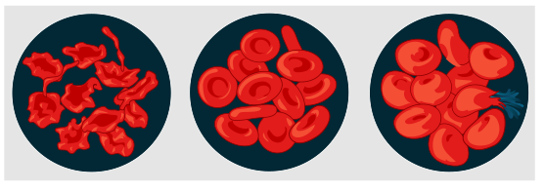

* 1. Describe the independent, dependent and at least 3 control variables for the red blood cell practical from (a) (4 marks)

* 1. The following results were obtained during the above experiment, create an appropriate graph to represent the data (5 marks)

|  |  |  |  |  |
| --- | --- | --- | --- | --- |
|  | Students | | | |
| **Trial number** | Sample A | Sample B | Sample C | Sample D |
| **Solution 1** | 7µm | 8µm | 6µm | 7µm |
| **Solution 2** | 10µm | 9µm | 9µm | 8µm |
| **Solution 3** | 4µm | 3µm | 4µm | 6µm |

* 1. Using the data from (c) determine which solution is the control, hypotonic anc hypertonic. Give reasons for your answer. (3 marks)